The 50th Annual
International Association for the Philosophy of Sport Conference
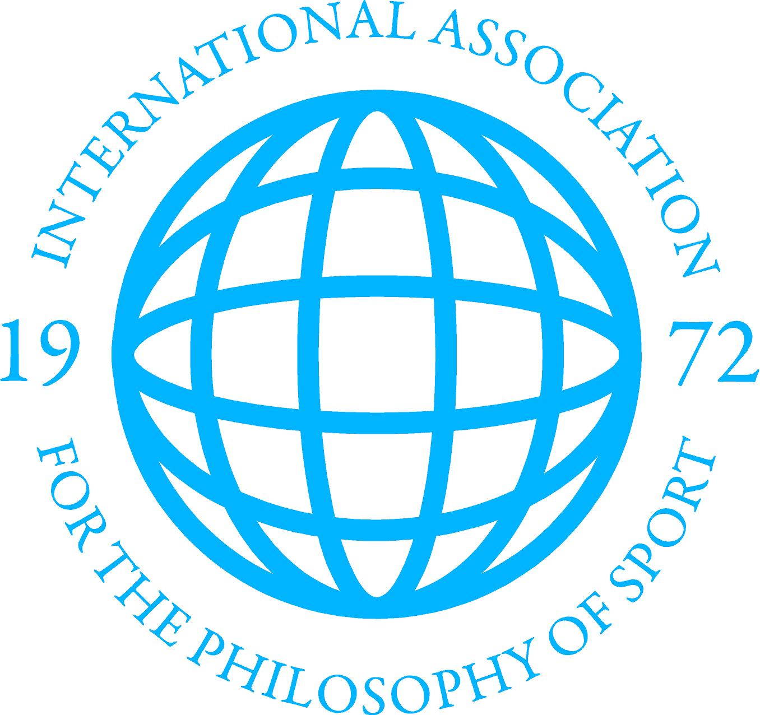
#IAPS2023

Radisson Blue Resort & Spa
Split, Croatia

September 19-22, 2023

Tuesday, September 19
10:00am – 12:00pm: IAPS Executive Meeting (for Exec members only)
11:00am – 1:15pm: Registration
1:15pm – 1:30pm: Conference Welcome
1:30pm – 3:00pm: Parallel Sessions 1
Room 1 | Room 2 | Room 3
Marx on Movement  - Aldo Houterman | Scales of Ignorance: an ethical framework to justify acceptable risk in sport classification regimes  - Alan Oldham | Resistance in Physical Education – the direct or indirect path to the top of the mountain  - Jens-Ole Jensen and Henrik Taarsted Jørgensen
Grounding – Should teachers work with their students´ and their own ability to stand still in contexts of movement?  - Lise Réol | Time preference and the Parfitian defense of risking brain injury in dangerous sport  - Eric Gilbertson | Commodified Authenticity: Questioning the Athlete Identity as a Vehicle for Politics in Sport  - Jacob Giesbrecht
The ontological significance of movement  - Qian Wang and Irena Martínková | From Competition to Inclusion: Competitive Sports in Special Olympics  - Jinfeng Sun | Formalism Reconsidered  - Paul Gaffney
Chair: Emanuel Hurych | Chair: Adam Berg | Chair: Arno Müller
3:00 – 3:15pm: Coffee Break

3:15 – 4:45pm: Parallel Sessions 2
Room 1 | Room 2 | Room 3 | Virtual
Fairchild’s Abjection: Rehabilitating a useful concept for Sport  - Angela Schneider and Alan Oldham | Democracy and Good Governance  - Breana McCoy | Why Have North American Sport Philosophers Ignored Race?  - Adam Berg | Disabled, but not in the Right Way: Exclusion in Paralympic Sport  - Jenny Schiff
Two Concepts of Sporting Excellence  - Steffen Borge | Remedies for Injustice in Sport  - Miroslav Imbrisevic | To mark or not to mark? Korfball through the lens of the elements of excellence  - Tafara Gary Chivasa | Boredom, Games, and Sport  - John Russell
Searching for Borderlands Between Sport Philosophy and Sport Science: Recommendations from Husserl and Merleau-Ponty  - Robert Scott Kretchmar | Mapping the landscape of sport competition integrity  - Mike Mcnamee and Marcelo Moriconi | How to recharge sport’s ethical core; plea for a materialist sport ethics  - Sandra Meeuwsen | A Preliminary Confucian Assessment of the Ethics of Sport Category Eligibility Criteria Vis-à-vis Transwomen Athletes  - Alex Pho
Chair: Heather Reid | Chair: Lev Kreft | Chair: Ask Vest Christiansen | Chair: Ryan Murtha
5:00 – 6:00pm: Opening Keynote: Professor John Sutton (Macquarie University) - What is it like to bat? Hitting, thinking, and the mind-body problem (Chair: Kenneth Aggerholm)
6:00 – 9:00pm: Welcome Reception
Attendees will be welcomed by:
Frane Žuvela, Dean of Faculty of Kinesiology, University of Split, Croatia
Matija Mato Škerbić, Research Committee for Bioethics of Sport, University of Zagreb
Kenneth Aggerholm, President of IAPS and Professor, Norwegian School of Sport Sciences

Wednesday, September 20
9:00 – 10:30am: Parallel Sessions 3
Room 1 | Room 2 | Room 3
Can We Make a Case for Elite Sport as Human Right? Examining a rights-based argument for trans-athlete inclusion  - John Gleaves | Fairness in Sport as Amateurism, Commercialism, and Professionalism  - Koyo Fukasawa | Sailing Experience: The emergence of a multiple way of being  - Maria Altimira Hackerott, Ana Cristina Zimmermann and Soraia Chung Saura
The Logical Consequences of Shifting from Fairness to Rights within the IOC’s Framework  - Ask Vest Christiansen | Intentional Rule–Breaking in EuroLeague Basketball – Professional Players Perspective  - Matija Mato Škerbić and Miloš Marković | Bodily Knowledge in Sport  - Arto Mutanen
Not Everyone Can be an Olympian: Gender and rights for limiting athletes in sport competitions  - Colleen English | Football for good? Analyzing the initiatives that aim to foster the "good game"  - Rafael Mendoza Gonzalez | “Sweat before Virtue” - On the Educational Value of Effort in Sport  - Heather Reid
Chair: Adam Pfleegor | Chair: Carwyn Jones | Chair: Kevin Krein
10:30am – 10:45am: Coffee Break

10:45am – 12:15pm: Parallel Sessions 4
Room 1 | Room 2 | Room 3 | Room 4 – Round Table Discussion
Meaningful Physical Education - philosophy in practice: Experiences from an action-research project  - Kasper Lasthein Madsen, Annemari Munk Svendsen | Sport and Politics?  - Lev Kreft | Grasshopper Logic  - Taliah L. Powers and Deborah P. Vossen | Trans inclusion in female sport  Panelists:  - Jon Pike  - Charlene Weaving  - Pam Sailors  - Javi Lopez-Frias  - Cesar Torres
Teaching Meaningful Physical Education in Primary School  - Esben Stilund Volshoej | The Increasing Political Power of the Sporting Gesture: Athletes and Alternative Forms of Communication  - Adam North | Does the “policeman and the footrace” example show the necessity of the lusory attitude or just the opposite?  - Eric Moore
The education for intercorporeality on school physical education: Toward to the corporeal “we”  - Kenji Ishigaki and Takuya Sakamoto | Strange Bedfellows: The Uneasy Relationship Between Sports and Politics  - Sanja Žarković | Understanding Bernard Suits’ Return of the Grasshopper: From the Alexandrian Condition to the Utopian Game Design Thesis  - Christopher Yorke
Chair: Lukáš Mareš | Chair: Lou Matz | Chair: Steffan Borge | Chair: Emily Ryall
12:15pm – 1:45pm: Lunch

1:45pm – 3:15pm: Parallel Sessions 5
Room 1 | Room 2 | Room 3 | Virtual Session
To what extent is a harm-reduction doping proposal ethically justifiable?  - Pavel Gregory Krippa | Fair Treatment? Sex Verification and the Eligibility Regulations for Female Classification  - Susan Hall | Sensation and Lived Experience  - Junko Yamaguchi | A Philosophical Argument for the Adoption of the Elam Ending in Basketball  - Ryan Murtha and Thomas Hunt
Guilty of Prohibited Association: Exploring Strict Liability and the moral responsibility of anti-doping organisations  - Joel Seickell | Competing Views of Competition  - Pam Sailors | First-Person Aesthetic Experiences in Sport  - Kevin Krein | Layered Conventional Theory of Sport  - Dylan Williams
The coach-young athlete relationship and doping: institutional paternalism and exploitation  - Nelson Morales & Angela Schneider | Ethical Issues Surrounding Female Athlete Reproductive Rights in a Digital Age  - Olivia Howe | Examination of “being and oughtness” and “the good and the right” in sports  - Hiraku Morita, Koji Takahashi and Takayuki Hata
Chair: Jim Parry | Chair: Charlene Weaving | Chair: R. Scott Kretchmar | Chair: Cam Mallett
3:15pm – 3:45pm: Coffee Break

3:45pm – 4:45pm: Parallel Sessions 6
Room 1 | Room 2 | Room 3 | Room 4 – Book Symposium
How to Be in the Body: Developing a Phenomenology of Physical Activity with Cerebral Palsy  - Ryutaro Ichihara | Sport philosophy in Portugal  - Luísa Ávila da Costa and Constantino Pereira Martins | On Nietzsche and modern sports  - Arno Müller | ‘Why it’s ok to be a sports fan’  - Alfred Archer  - Jake Wojtowicz  - Adam Kadlac  - Nina Windgätter  - Nathaniel Baron-Schmidt
Sport and being-towards-death: possibility, anxiety and authenticity at the Transplant Games  - Gareth Wiltshire | Bioethics of Sport as a Subject at the University of Belgrade  - Sandra Radenović, Miloš Marković and Branka Savović | The tragic dimension of sport as an affirmation of life and power of destiny  - Odilon José Roble
Chair: Sandra Meeuwsen | Chair: Miroslav Imbrisevic | Chair: Irena Martinkova
4:45pm – 5:00pm: Break
5:00pm – 6:00pm: Keynote: Professor Ivana Zagorac (University of Zagreb) – Emotions in sport: an interesting case of shame and guilt (Chair: Alfred Archer)

Thursday, September 21
9:00am – 10:30am: JPS Editorial Board Meeting (for editorial board members only)
10:00am – 10:30am: Coffee Break
10:30am – 12:00pm: Parallel Sessions 7
Room 1 | Room 2 | Room 3
Commercializing Women’s Sports: How Far do we want to Go?  - Nina Windgätter | Athletes safeguarding first. Ethical guidelines for safe AI in sports  - Alberto Carrio | When the Chips are Down … Just Be There: Athletic Performance and Mindfulness  - Maja Smrdu and Jesus Ilundain-Agurruza
Big Air, $pins & Objectification: An analysis of Olivia Dunne and Eileen Gu  - Charlene Weaving | Gamification supported by AI: challenges and threads for the field of movement activities  - Emanuel Hurych | Physical Literacy and Somaesthetics: A Rejuvenating Combination for the Elderly  - Yan Huang and Jesus Ilundain
Looking at Bodies in Sports  - Leslie Francis and John Francis | The Ontology of Being in Games  - Emily Ryall | Embodied listening: Exploring embodied forms of ‘thinking’ in Tai Chi oppositional practice  - Sara Kim Hjortborg
Chair: John Gleaves | Chair: Chris Yorke | Chair: Doug Hochstetler
12:00pm – 1:30pm: Lunch

1:30pm – 3:00pm: Parallel Sessions 8
Room 1 | Room 2 | Room 3 | Room 4
Power, Sex & Corruption in Sport: Sextortion, an international examination into a silent abuse of power  - Whitney Bragagnolo and Yanei Lezama | The Aesthetics of 'Purposive' Sports: A Critical Re-Appraisal  - Bill Morgan | The Real Ethical Problems with Strategic Fouling in Basketball  - Lou Matz | ‘Philosophising with Athletes and Their Coaches’: On Using Philosophical Thinking and Dialogue in Sport  - Lukáš Mareš
Dr. Eva Carneiro's Syndrome  - Marija Andjelkovic, Nenad Dikic and Sanja Zarkovic | Aesthetic reading of velocity in contemporary sports  - Teresa O. Lacerda and Luísa Ávila da Costa | The Implementation of The Challenge System in Football  - Vid Kučko | Exploring a Subjectivist Perspective of Meaningful Work for Sport Employees  - Claire Zvosec and Nathan Baer
Sport, Self-confidence, and Gender Violence  - Sylvia Burrow | Are music competitions sports – according to the acknowledged definitions of sport?  - Filip Kobiela | The Normative Status of Sports Penalties  - Erin Flynn | The Capabilities Approach and Hunting: A Review, Critique, and Development  - S.P. Morris
Chair: Colleen English | Chair: Jesus Ilundain | Chair: Sigmund Loland | Chair: Mike McNamee
3:00pm – 3:15pm: Coffee Break

3:15pm – 4:45pm: Parallel Sessions 9
Room 1 | Room 2 | Room 3 | Virtual
Esports, Real Sports and the Olympic Virtual Series  - Jim Parry and Jacob Giesbrecht | The Sport Epistemology of Paul Weiss  - Xiaolin Zhang | The Issue of Gene Doping through the application of CRISPR-Cas9 technology  - Yoshiko Oda, Yoshitaka Kondo and Soichiro Toda | Gamifying Health: The Bioethics of Wearable Devices and Fitbit’s Transformation of Fitness and Movement into a Game  - Cam Mallett
Esport: Human After All  - Mike Griffiths | Sport in a new cognitive context  - Djordje Stefanovic | A Map of Ethical Discourses in Doping Scholarship  - Douglas Hochstetler, G. Fletcher Linder and Jason Ball | Artificial Intelligence (AI) in Sport - a critical analysis  - Marwan Hellal
Sport In the Metaverse: Is it conceptually possible?  - José Luis Pérez Triviño | Overcoming dualism in movement skills research: an integrative approach  - Sigmund Loland, Øyvind Sandbakk and Gertjan Ettema | Disorder in Sport: pathologizing (sporting) normalcy  - Carwyn Jones
Chair: Filip Kobiela | Chair: Jon Pike | Chair: Eric Moore | Chair: Alex Pho
4:45pm – 5:00pm: Break
5:00pm – 6:00pm: IAPS Presidential Address – Professor Kenneth Aggerholm - Sport Humanism: Contours of a Humanist Theory of Sport (Chair: Charlene Weaving)
8:00pm – 10:00pm: Conference Dinner (for those that have registered their attendance in advance)

Friday, September 22
9:00-10:30am: Parallel Sessions 10
Room 1 | Room 2 | Room 3 | Room 4
Preferences, Goods, and Aesthetic-Ethical Conflict in Nature Sports  - Leslie A. Howe | Can basic action be difficult? Can non-basic action be simple? Action theory and automatization in sport  - Rafał Adametz | Two Concepts of Rules in Sport  - Daniel Hague | A Defence of Foul-weather Fandom  Alfred Archer and Georgina
Ultra Sports as Nature Sports Proper  - Irena Martinkova | An Essentialist Theory of Sport (synopsis)  - Jon Pike | What principles should coaches abide by? The case of placebo use in sport  - Marcus Campos, Pascal Borry and Mike McNamee | Mills Striving, Embodiment, and Sociality in Sport  - Michael Rohlf
Ecocentrism, Sustainability, and Nature Sports  - Adam Pfleegor | Ready, Player Two? Joint action and the limitations of methodological individualism about sport  - Gordon Birse | Advocate Athletes Who Have Been Accused Without Valid Evidence  - Nenad Dikic, Marija Andjelkovic and Sanja Zarkovic | Antisemitism In European Football  - Rafael Valencia
Chair: S.P. Morris | Chair: Xiaolin Zhang | Chair: Douglas McLaughlin | Chair: Teresa Lacerda
10:30 – 10:45am: Coffee Break

10:45am – 12:15pm: Parallel sessions 11
Room 1 | Room 2 | Room 3
Philosophical assumptions to understand bodybuilding as a sport and its specific skills  - Paulo Boccati and Odilon Roble | ***Kretchmar Student Essay Winner***  When "Higher, Faster, Stronger" Implies Harm. Ethically characterizing violence in elite sport  - Yaneí Lezama | Archery: a traditional game in the scope of phenomenology of image  - Soraia C. Saura and Ana C. Zimmermann
The Importance of Pick-up  - Douglas McLaughlin | Broken body: anthropo-philosophical observations on Muay Thai  - Constantino Pereira Martins | The notion of harmony: reflections from traditional games with Brazilian indigenous peoples  - Ana Zimmermann, Soraia Chung Saura and Bernard Andrieu
Play and the good life in sport: A question of swinging in and out of control?  - Ole Lund and Kasper Lasthein Madsen | Hidden reality: fetishism in sport  - Jernej Pisk | Cowboy Professionalism: A Cultural Study of Big-Mountain Tourism in the Last Frontier  - Forest Wagner
Chair: Michael Rohlf | Chair: Nina Windgätter | Chair: Pam Sailors
12:30 – 1:30pm: Keynote, 2022-23 Warren Fraleigh Distinguished Scholar – Professor Ivo Jirásek – “The hand of God”: hierophany and transcendence through sport (Chair: Paul Gaffney)
1:30 – 2:30pm: IAPS AGM – all members are invited to attend
2:30pm: Conference Close

